Request for Proposal



Network Operation Center
and
Engineering Services

November 19, 2019
Table of Contents
Introduction 3
Opening Instructions 4
RFP Schedule of Events and Dates 5
Table 1 - RFP Events and Dates 5
Response Requirements 5
Evaluation Process 6
Further Proceedings 6
Overview 8
Network Architecture 9
Figure 1 – MCFN Network Fiber Plant 9
Network Architecture and Operational Details 10
Customer Premise Equipment 11
Table 1 – NNI Connection Points 12
Engineering Services – What is Needed 12
Engineering Services – Price Matrix 13
Table 2 – Engineering Pricing Matrix 13
Engineering Qualifications 13
Network Operation Center Services 15
Background 15
Monitoring System 15
Services Checklist – IP Network Monitoring and Problem Management 16
Table 3 – Network Monitoring and Problem Management 16
Provisioning 17
Device Configuration Management 17
Asset Data Management 17
NOC Pricing – Monitoring and Device Integration 18
Table 4 – NOC Pricing Matrix (Monthly Costs) 18
Added Value 18
Appendix A – Customer Premise Equipment 19
Appendix B – NOC Monitoring KPI’s 20

Introduction
In 2006, the Medina County Commissioners announced their intent to make fiber broadband access more widely available throughout the County in support of governmental use (including to serve the County’s needs as well as those of other governmental users, including municipalities, school districts, libraries and others), access for governmental and non-governmental providers of public services in the County (including educational, healthcare, research, cultural and other community institutions) and economic development (including retention and expansion of existing businesses, attraction of new businesses, facilitating job training and education). The Medina County Fiber Network (MCFN) is intended to provide a platform to promote all of those purposes at a cost that is acceptable to the County and the Medina County Port Authority (MCPA), effectively creating an e-Corridor linking the participants, not only to one another, but also to carrier facilities and carriers throughout the region and serving as a gateway to alternative networks and services.
This Request for Proposals (RFP) is issued by the MCPA in order to receive proposals from respondents (Respondents) who are willing and able to provide the MCFN in accordance with the requirements of this RFP and who are willing to work with the County and MCPA toward a final engineering design and installation in addition to network operation center services. MCPA and Medina County specifically reserve the right to reject any and all Proposals, at any time and for any reason or no reason, the acceptance of any Proposal and the decision to continue with the MCFN being in the sole and absolute discretion of the County (acting through the Commissioners) and MCPA (acting through the Board).
As further described in this RFP, the County, MCPA and MCEDC will not be responsible for any costs incurred by any Respondent in preparing and submitting its Proposal or otherwise in respect of responding to this RFP.

[ REMAINDER OF PAGE INTENTIONALLY LEFT BLANK ]

Opening Instructions
Carefully read the information contained in this RFP and submit a complete response to all requirements, specifications, and questions to MCPA as directed herein or requested by MCPA or the County. The address of the Port Authority is as follows:
Medina County Port Authority
144 North Broadway
Medina, OH 44256
Phone: 330.722.9215
Contact for this RFP:
David Corrado
Medina County Fiber Network
144 North Broadway
Medina, Ohio 44256
Phone: 216.832.7059
dcorrado@fibercounty.com
Questions and Inquiries
Respondents who have questions about the RFP should e-mail such questions to the above-named Contact for this RFP (herein Contact) by the dates noted in the RFP schedule in Table 1.
Every effort will be made to post all questions and answers within 3-5 working days via distribution emails to all participants.
Responses to questions which involve an interpretation or change to this RFP will be issued in writing by addendum and e-mailed to all parties recorded by MCPA as having received a copy of the RFP and having elected to proceed with responding to the RFP.

It is the responsibility of the Respondent to ensure MCPA has the correct contact information. All addenda issued prior to the time that proposals are received shall be considered part of the RFP. Only additional information provided by formal written addenda shall be binding. Anyone receiving a copy of this RFP other than directly from MCPA is responsible for notifying the Contact that they are in receipt of an RFP package and for providing a name, address and e-mail in the event an addendum is issued.

This RFP Word document is not locked or password protected which allows the Respondent to enter responses directly into the appropriate section. Do not submit responses under separate cover. All responses should be entered into the appropriate sections within this document.
All materials submitted in response to this RFP will, upon receipt, become the sole property of MCPA and may become a part of any contract relating to the MCFN regardless of whether submitted by the contracting party. The Respondent, by acceptance of this RFP agrees that any cost incurred in responding to this RFP, or in support of activities associated with this RFP, any response whether or not resulting in a Proposal, and any efforts of the Respondent, whether or not at the request of MCPA or the County in connection with the transactions contemplated by this RFP, in the absence of an express written contract approved by the Commissioners and the Board, shall be borne solely by the Respondent and cannot be billed to MCPA or the County. MCPA and the County will incur no obligation or liability whatsoever to anyone by reason of issuance of this RFP, or action by anyone relative thereto.

RFP Schedule of Events and Dates
All events and dates are subject to change. MCPA will give reasonable notice of changes via email and notification to those continuing in the RFP process.

RFP Event | Projected Schedule
RFP Release | November 19, 2019
Intent to Respond Notification; All Questions Submitted | December 2, 2019
MCPA-Issued Responses to All Respondent Questions | December 9, 2019
Proposals Submitted to MCPA | December 20, 2019
Proposal Review Begins | December 23, 2019
Proposal Selection | December 31, 2019

Table 1 - RFP Events and Dates

Response Requirements
Time for Submission
The closing date and time for submitting a Proposal as noted in the RFP Schedule will be December 20, 2019 at 5pm. Any responses received after that time on that closing date will not be accepted.

Response Submissions and Opening
Proposals submitted in response to this RFP must be submitted via email only which includes a read receipt. It is the sole responsibility of the Respondents to ensure that their responses arrive in a timely manner.

Evaluation Process
The MCPA will review the accepted Proposals with the County based on the evaluation criteria listed below and the value to MCPA and the County. MCPA and the County will form a task force to review the Proposals and the task force will compare and rank the Proposals, based on the Evaluation Criteria below and using a point-based weighted ranking system, as set forth under “Evaluation Criteria” below. Once that objective evaluation is made, each Proposal will also be evaluated, and all Proposals will be ranked, based on the subjective criteria listed under “Value to Medina County” below. MCPA and the County reserve the right, at any time and for any reason or no reason, to reject any and all Proposals.

Evaluation Criteria
Understanding of Scope of Work 15 Points
Network Operation Center Capability 15 Points
Engineering Services Offering and Capability 25 Points
Price 45 Points

Total 100 Points

Further Proceedings
The option of whether or not to initiate negotiations rests solely with the County Commissioners and the MCPA Board. If those Boards elect to initiate contract negotiations, these negotiations can involve changes in the MCPA’s requirements or the Respondent’s Proposal which could, by their nature, affect the basis of selection. The Respondent will remain responsible for all expenses during any contract negotiations.
Final negotiations, terms and acceptance, if any, of all or any portion of any Respondent’s Proposal will be in the sole and absolute discretion of the MCPA Board and the County Commissioners. The County and MCPA reserve the right to reject any and all Proposals at any time and for any reason or no reason, and to reject or accept any Proposal in whole or in part.
The schedule is not and will not be fixed. The County and MCPA intend to proceed with all reasonable speed throughout the process. In the event that more than one Proposal is found worthy of consideration, in whole or in part, and acceptance of one Proposal, in part, would not impede or affect the consideration of another response, the County and MCPA will seek to move forward with each response as quickly as reasonable.
At any time, the County or MCPA may choose to continue discussions or negotiations with a particular Respondent, terminate discussions or negotiations with a particular Respondent while continuing discussions or negotiations with other Respondents or conclude discussions or negotiations with all Respondents.
The MCPA also reserves the right, at any time and from time to time, to:
- Request clarification or additional information from any Respondent.
- Waive immaterial defects or minor irregularities in responses.
- Modify, remove, or add requirements to the RFP and suspend or re-open the RFP process.
- Separate services and service delivery areas in the County, and consider Proposals by different Respondents to provide different services to MCFN users or provide services in different service delivery areas, on a nondiscriminatory basis.
- Reject any or all responses and terminate the RFP. As noted, costs incurred by any Respondents in the preparation of the response to this RFP are the Respondent's responsibility, and will not, under any circumstances, be reimbursed by the County or MCPA.
- CANCELLATION – The MCPA reserves the right to cancel further proceedings pursuant to this RFP for any reason. In no event shall the County or MCPA have any liability for such cancellation.
7. STATE AND FEDERAL LAW COMPLIANCE - Successful Respondents who develop a contractual relationship with the MCPA to provide some or all of the services contemplated in this RFP shall be expected to agree:
- to make payment promptly as due to all persons supplying the Respondent with labor or materials for carrying out the work provided for in its contract with the MCPA;
- to not permit any lien or claim to be filed or prosecuted against the County or the MCPA on account of any labor or material furnished; and
- to comply with all applicable Contract provisions required by Ohio State law or otherwise described in this solicitation. Successful Respondents who develop a contractual relationship with the MCPA shall also agree to comply with all applicable Federal and Ohio State laws relating to workers' compensation, unemployment compensation, taxation, and health and safety. The attention of all Respondents is directed to State, Federal and local law prohibiting discrimination in employment, which shall be applied to any successful Respondent.

Overview
The MCPA is seeking a partner who has extensive capabilities in the monitoring and operations of a fiber network from real time 24x7 alert and proactive procedures through backbone engineering and provisioning of customer laterals.
The remainder of this document outlines technical requirements necessary for a potential provider to submit a proposal for providing engineering and monitoring services. A respondent can submit documents supporting their proposed solution(s) for either sections, Network Operations Center or Engineering Services; however, a respondent who can provide a solution for both sections will receive a higher score. The MCPA reserves the right to award multiple contracts, if necessary, depending on the respondent capabilities.
The MCFN has been operational for 7 years. The network will require re-engineering as we grow and react to customer needs. The duration of this award is for one year with a two-year renewal option. After 12 months, depending on the state of the network, the award recipient will be able to renegotiate price applicable to the number of customers.
The recipient who is awarded this contract will also be considered, as a first choice, for a fiber to the home project which MCFN is initiating on April 1,2020. The initial phase of this project covers 6,500 homes but will be extended to 50,000 homes within the next 3-5 years. Pricing for both the commercial and residential portions of this RFP will be weighted equally.

[ REMAINDER OF PAGE INTENTIONALLY LEFT BLANK ]

Network Architecture
The diagram below shows the current network architecture and will be referred to throughout the remainder of this document.
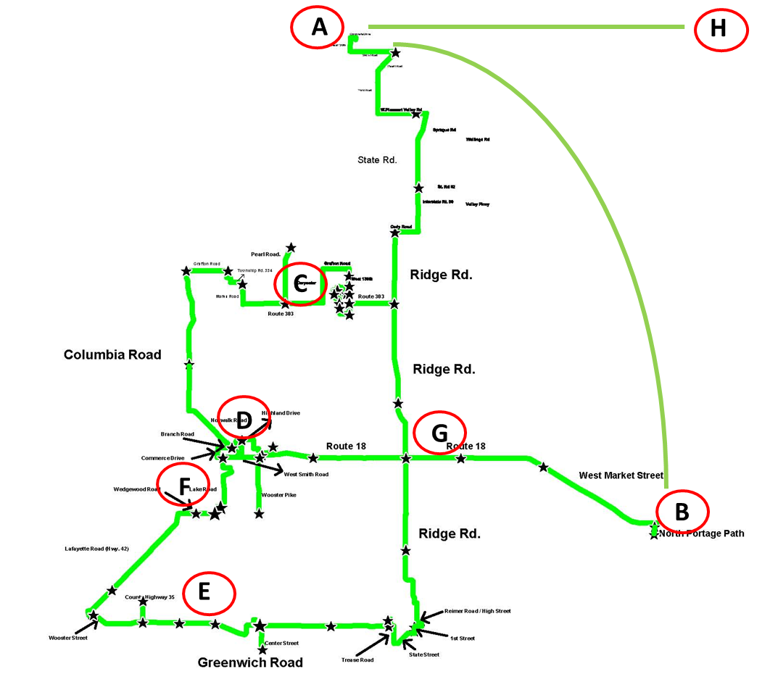
I

Figure 1 – MCFN Network Fiber Plant
Legend

A - Head-end location at Aegis Data Center, 12875 Corporate Drive, Suite A, Parma, Ohio 44129
B – Head-end location at One Cascade Plaza, Akron, OH 44308
C – Access node at Brunswick City Hall, 4095 Center Road, Brunswick, Ohio 44212
D –Access node at Medina County Administration Bldg., 144 N. Broadway, Medina, OH 44256
E – Access node at Westfield Center City Hall, Greenwich Road, Westfield Center, OH 44251
F – Access node at Medina County University Center, 6300 Technology Lane, Medina, OH 44256
G – Access node at 1153 Medina Road, Medina, OH 44256
H – Two single-mode fiber strands terminating at 1621 Euclid Avenue, Cleveland, OH (Keith Building)

Network Architecture and Operational Details

The MCFN is comprised of approximately 150 miles of 144-count single mode fiber. Five access nodes (C, D, E, F and G) are used to attenuate signal and receive local fiber termination. Three data centers (A, B, and D) as both access nodes and data center head-ends. Data centers H and I have Medina County Fiber Network equipment for NNI’s with other carriers and for terminating large circuits from Medina County customers.

DWDM NODES  Ciena 5160 | PHYSICAL PEC | Access Node / IP | CLEI | Serial Number | Location
MC-DW-AEGIS-001 | NTK503KA | 10.1.7.11 | WOM4P00ERA | NNTMRT0DKCTT | Everstream Data Center
MC-DW-CASCA-001 | NTK503KA | 10.1.1.11 | WOM4P00ERA | NNTMRT0D8H33 | Cascade Plaza
MC-DW-INVOL-001 | NTK503KA | 10.1.10.11 | WOM4P00ERA | NNTMRT0DKCRG | Involta
MC-DW-MEDAD-001 | NTK503KA | 10.1.5.11 | WOM4P00ERA | NNTMRT0D8H32 | Medina County Administration Building

Ciena 5142 | Serial Number
AEGIS-001 | M8378336
AEGIS-002 | M8771735
BRUNS-001 | M8378335
BRUNS-002 | M8378331
MEDUC-001 | M8359338
MEDUC-002 | M8903457
MEDAD-001 | M8378352
MEDAD-002 | M8623420
MEDAD-003 | M8903484
PLVAL-001 | M8376955
PLVAL-002 | M8520950
WESTF-001 | M8377040
WESTF-002 | M8617670
CASCA-001 | M8378353
CASCA-002 | M8771674
INVOL-001 | M8358779
KEITH-001 | M8378350
ATTPP-001 | M8378428

Network configurations are controlled by our current NOC, who also provides engineering services and CPE provisioning.

Medina County Fiber provides an open architecture that provides layer-2 transport only for other carriers to bring their IP services into Medina County. The desired network provides equipment interfaces to carrier equipment using VLAN’s to segregate lateral traffic. Any layer-3 protocols such as MPLS, VPN or voice protocols are provided and configured through a carrier NNI.

All customer contracts are held by the partner carrier. The MCFN does not write direct contracts with customers for the following reasons:

- Consolidated invoicing – most customers prefer to be billed by one carrier and the Medina County Port Authority can only sell transport services.
- Single point of contract – customers have a single phone number to contact, which is the carrier’s NOC. If a carrier’s NOC needs to contact the MCFN NOC, a level 2 communication is established between the two facilities to debug open issues.
- Customers are more comfortable signing with a carrier who has an established business and a large install base.
- Carriers who provide voice services normally have a telecommunication billing system that has call detail records.
- With the carrier of record holding a single contract with the customer, customer advocacy is ultimately the responsibility of the carrier rather than split between the carrier and the MCFN. This allows the carrier of record complete control over customer satisfaction and contract renewals.

The Medina County Port Authority does invoice those customers that require only transport services, either as a point-to-point or transport from a customer premise to a data center. Medina County Fiber also leases dark fiber IRU’s to other carriers and customers.

The fiber network is distributed into three (3) types of fiber uses:

- Transport fiber – 144 strand fiber that transverses the entire network. Access nodes are connected through two pairs of fiber, configured in a 20 Gbps lag. Other fibers reserved are for DWDM services and, most recently, fiber to the home middle mile transport.
- Star fiber – fiber reserved for local loops, creating redundant networks for geographically close locations.
- Local fiber – lateral fiber from customer premise to an access node. SFP’s using a single pair of fiber or a single fiber (Bidi) are used currently but single fiber SFP’s are desired.

Customer Premise Equipment

Customer equipment used to terminate local fiber consists of Juniper, Ciena and Adva (MRV) systems. The current standard is an MRV 606 but Ciena 3904’s are used when redundant and/or data center power is needed. Juniper equipment was inherited from the initial company that ran the network but are slowly phased out as they fail in the field.

The company we choose will need to demonstrate they can configure these CPE’s and integrate them into the current backbone.

Device Type
CN3904
JUNIPER-EX-SERIES
JUNIPER-SRX-SERIES (monitoring gateway)
MRV-OPTISWITCH-606

Network NNI’s connect the following carriers to the Medina County Fiber Network:

Carrier | NNI Location
AT&T | AT&T Akron, OH POP
Cogent | Keith Building, Cleveland, OH
Fusion | Keith Building, Cleveland, OH
Crown Castle | Cascade Plaza, Akron, OH
CenturyLink | Cascade Plaza, Akron, OH
First Communications | Cascade Plaza, Akron, OH
Bresco Broadband | Involta Data Center, Akron, OH
Lightspeed Technologies | PLVAL Access Node, Medina, OH
Fairlawn Gig | Cascade Plaza, Akron, OH
OARnet | Cascade Plaza, Akron, OH
Everstream | Everstream Data Center, Parma, OH

Table 1 – NNI Connection Points

Engineering Services – What is Needed

- Points C, D, E, F and G are access nodes which, currently, are Juniper 4200’s. This equipment must be configured to work with the new MCFN architecture, supporting existing customers and providing a platform for adding new customers. We have standardized on Ciena equipment for our backbone and distribution nodes.
- The link between points A-H is a two strand, single mode IRU fiber purchased from Crown Castle. This link terminates into the Keith Building to support existing carriers and to provide additional NNI’s with Keith Building carriers.
- The link between points A-B is a two strand, single mode IRU fiber purchased from FiberTech. This link provides network path redundancy, establishing a protect mode for the three rings with a 3ms failover for the Medina County Fiber Network backbone.
- Customer and carrier on-boarding services, which include placement and configuration of customer premise equipment and circuit provisioning for new customers and integration of carrier services onto the MCFN, are the operational, on-going engineering services needed for the network.
- We employ an unprotected DWDM network that connect points A, B, D and I. In addition to providing a 10 Gbps backbone link between points A & B, the DWDM supports 20 Gbps (two 10 Gbps circuits) from a large customer to point I for offsite backup services.

Engineering Services – Price Matrix

Please complete Table 2 below, in US Dollars, in addition to providing any notes related to the pricing. You can add lines to the table for any bundled pricing, etc. that you might offer beyond hourly services. Use “N/A” for any cells not applicable. The engineer(s) assigned to work with Medina County Fiber will be required to participate in a weekly contractor meeting for approximately one hour. Include, in the table below, a cost, if one exists, for this meeting period.

Service | Hourly Rate | One Time Cost | Notes
Backbone Engineering
CPE Configuration
General Troubleshooting
Meetings

Table 2 – Engineering Pricing Matrix

We rely on our NOC to purchase CPE and backbone equipment in addition to network items, such as SFP’s for the Ciena 6500’s. Explain below your ability to fulfill this requirement.
Equipment Purchasing Ability

Engineering Qualifications

This section focuses on the Respondent’s engineering resources and qualifications of those resources that will be supporting the MCFN. The questions below relate to Juniper equipment, which is the current configuration. If the Respondent is proposing an equipment swap, be sure to identify the platform and certification levels of the engineering resources.

a) List the number of engineers who have Juniper, Ciena and Adva (MRV) experience, the number of years of experience for each engineer and the certifications held by each engineer.

b) Larger companies within Medina County will require RSTP failover using redundant routes. Discuss your approach to using RSTP related to the Medina network. Be specific.

c) List how many customers are supported by your organization that uses a Juniper, Ciena and/or an Adva network environment.

d) From a customer standpoint, how would you deploy last mile CPE and describe the contents of your design package.

e) Discuss how you will evaluate traffic flow across the network from a capacity perspective.

f) Describe how to test the physical optical layer within each CPE types.

g) Detail your approach to configuration backup policies.

h) List at least three customer resources that utilize your firm for engineering services.

i) Discuss your hardware procurement capabilities for the hardware types discussed in this RFP.

[ REMAINDER OF PAGE INTENTIONALLY LEFT BLANK ]

Network Operation Center Services

Background

It is preferred that a Respondent is directly connected to the Medina County Fiber Network via layer-2. However, Internet based monitoring will be accepted and evaluated but layer-2 connectivity will take precedence. If a Respondent is not geographically close to the MCFN, the price for connecting to the MCFN should be presented separately from the monitoring price.

All backbone and CPE will need to be monitored to the dmarc location. Equipment on the local area network side or equipment used by partner carriers to deliver layer-3 services will not require monitoring.

Monitoring System

a) How many people are in your NOC?

b) How many people support your NOC after-hours, weekends and holidays?

c) How many customers are monitored by your NOC?

d) How many Juniper networks are monitored by your NOC?

e) What is the number of end-nodes monitored by your NOC?

f) How do you monitor a fiber cut?

g) Discuss the workflow system and how it applies to a customer incident.

h) Explain the security measures employed by your NOC.

i) Describe your problem management system.

j) Detail your on-boarding process for new customers.

k) Discuss the capability and interface related to your customer portal.

l) What is the annual turnover of your 1st level NOC agents?

Services Checklist – IP Network Monitoring and Problem Management

Table 4 shown below list a number of general services that are needed in monitoring the MCFN. Next to each service, answer “included” or “omitted” as to whether this service is part of your monthly pricing.

Service | Answer  (Included or Omitted) | Comments
Problem monitoring and management
Threshold monitoring for network conditions and proactive alarm generation
Problem detection, isolation, dispatch and resolution
Router (switch) access security management
Capacity management and utilization reports upon request
Inventory database of all managed elements including device configurations
Incident records and reports
Trouble ticket generation
Engineering dispatch services
Quarterly capacity reporting

Table 3 – Network Monitoring and Problem Management

Provisioning

The Respondent will be required to work with the MCFN fiber management partner and any carrier who is connected into the MCFN regarding the provisioning of new circuits and the dispatching of customer premise equipment.

All lateral IP services are provided by carrier partners with the MCFN providing transport services only. Therefore, all new customer provisioning will include a partner carrier. The Respondent will be required to provide provisioning services that include the placement and configuration of customer premise equipment (if Respondent is bidding on both engineering and NOC services, pricing for provisioning should be included in the engineering section).

Device Configuration Management

The Respondent will record, maintain and implement all variable configuration parameter details and operating configuration files of every device comprising the MCFN optical network infrastructure that is within the control domain. The Respondent will routinely and periodically review actual configuration settings of those devices under its control, confirm the validity of those settings and investigate and resolve configuration discrepancies identified in that process.

Asset Data Management

Describe your process for inventorying and managing network assets. Include in your discussion the initial inventory process and change management process for adding assets to the MCFN. Also include software management and version and revision control.

NOC Pricing – Monitoring and Device Integration

Device Type | Monthly Cost | One-Time Cost | Notes
CN3904
CN5142
CN5160
JUNIPER-EX-SERIES
JUNIPER-SRX-SERIES
MRV-OPTISWITCH-606
OME6500
Residential CPE
NOC pricing includes monitoring and integration of network devices. Detail any costs on a per incident basis that are not included in the monthly cost.

Table 4 – NOC Pricing Matrix (Monthly Costs)

Appendix B shows the monthly KPI’s and the types of alarms that are configured today. This data set is not set in stone. If a respondent believes that fewer MIB’s can be set without impacting the information needed to provide a clear picture of network performance, thus producing a lower monthly price, this rationale should be documented and explained in the box below.
Alarm Setup Description

Added Value

This section asks the Respondent to provide any value-add services that the Respondent can apply to the MCFN. Value add services include carrier relationships such as introducing new carriers into the MCFN, providing a sales force for revenue generation, or any service that would add to the success of the MCFN. Be specific as possible.

Appendix A – Customer Premise Equipment

CN3904 16
JUNIPER-EX-SERIES 66
JUNIPER-SRX-SERIES 1
MRV-OPTISWITCH-606 74

Appendix B – NOC Monitoring KPI’s

